**In the Garden…**

**Nourish the Land – Simply - to Reap its Rewards**

(Many ideas in this article were obtained from a website <http://www.treesaregood.com/treecare/mulching.aspx> .

Article by S. Manning, Tribal Environmental Director.)

The soil under our feet on the Big Pine Indian Reservation is good soil for cultivation in Owens Valley. Granted, on the west side of the highway, there may be a few too many large rocks, and you may look down where you’re standing and see “sand.” Indeed, our soil has been classified on a scale from loamy sand to “very gravelly loamy coarse sand.” Nevertheless, this is a soil that, with a little effort, can be extremely productive.

There are a few facts about soil that people rarely think about. For one, it’s generally a good thing for soil to be porous, because plant roots need oxygen. Also, in an arid climate like ours, well-drained soils reduce the chances of salt build-up, and salts can interfere with plant growth. Finally, it’s not just dirt; “soil” is a complex and valuable resource. Soil is the sum of its mineral content, the living things in the soil, and all the historical and environmental influences it has endured over the eons. Soil is vital to human life, but it is easily destroyed. In 1937, U. S. President Franklin D. Roosevelt accurately noted: *"The nation that destroys its soil destroys itself"*.

Soil will vanish if abused, but if respected and cared for using very simple steps, soil will remain and flourish.

Think of your soil as a living thing that must be cared for. In fact, a healthy soil should be teeming with beneficial microorganisms, each with a specialized function, and all working together to maintain balance in the local ecosystem beneath your feet. Because of its living things, water and protection from temperature extremes are two easy things to provide to soil, and one of the best ways to achieve both is to grow plants. In contrast, compacting the soil, leaving it bare and exposed to the elements, or adding oils or chemicals, will destroy the soil’s overall innate ability to persist and be productive.

Mulching and composting are two simple procedures for caring for soil. In fact, mulching is one of the easiest and most beneficial things you can do for perennial, woody plants, such as trees. The remainder of this article will discuss mulches derived from plants (chipped wood, or cut grass or hay). It is true that mulches can be “inorganic,” such as stone, rubber, or synthetics, but these often never decay and some provide less overall benefit.

Mulches are materials placed over the soil surface. Properly applied, mulch can give landscapes a handsome, well-groomed appearance. Proper mulching:

* Is applied as a thin layer (2 to 4 inches thick) extending out the distance of the plant canopy (or “drip line”).
* Helps maintain soil moisture. Evaporation is reduced, and the need for watering can be minimized.
* Helps control weeds. A 2- to 4-inch layer of mulch will reduce the germination and growth of weeds.
* Insulates: it keeps soils warmer in the winter and cooler in the summer.
* Can improve soil structure (aggregation of soil particles), giving it the right amount of pore space.
* Should improve soil fertility.
* Can inhibit certain plant diseases.
* Will help you realize when you’re getting too close to tree trunks with the weed-whacker or mower.
* Can give planting beds a uniform, well-cared-for look.

Like any natural remedy, too big a dose can be harmful. Mulch should be applied appropriately; if it is too deep or if the wrong material is used, it can cut off the oxygen supply to roots, thereby harming landscape plants. After mulching, keep an eye on the plants: if they are not thriving, consider rearranging the mulch.

A “mulch volcano” would be a sign that you’re overdoing it; this would be mulch piled up around the base of a tree, making the tree look like it’s rising from a volcano! Although this approach may be effective in suppressing weeds and reducing maintenance, it often causes aeration and pest problems.

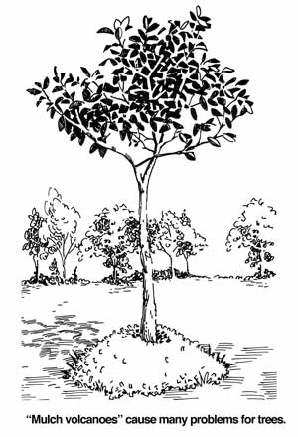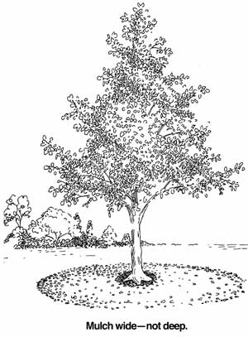

|  |
| --- |
| The illustrations are from: <http://www.treesaregood.com/treecare/mulching.aspx> |

Why Mulch

Mulching using yard waste is a form of recycling that really makes sense. If you are growing, then cutting, so much vegetation that you feel a need to haul it away every once in a while, maybe it’s time to rethink your landscaping design and goals. Your yard should live within its means! When plants grow in your yard, they consume water and nutrients. When they die (or when they are cut), they will decompose into the nutrients from which they are built. Placing your own yard clippings back on the surface as mulch (or in a compost pile) directly recycles your yard’s own nutrients, keeping them for your soil’s and living plants’ reuse. The alternative is use of fossil fuels to haul vegetative debris somewhere else where it may or may not eventually break down. Not only does this toss away beneficial nutrients, it also tips the ecological balance by depositing the nutrients in a place they didn’t originate and where they may be accumulating to toxic levels.

The Environmental Department will turn limbs and clippings into mulch, using our light-duty chipper. We desire to work with community members to recycle the local nutrients, for your benefit. Please call Levi Mallory, (760) 937-5058, to arrange a time for him to come chip on your property. Many limbs can be reduced to just the right amount of organic mulch.