***MARCH-MAY: PULL TUMBLEWEEDS, WHEN THEY’RE SMALL!!***

Spend a few minutes outdoors pulling out all you see. The whole family can participate! Later: You’ll have very few, or even *none* if you’ve done a very good job!

How to Identify a Tumbleweed Seedling:

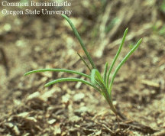

Fleshy, succulent leaves. Very fine “spine” at leaf tip.

Pairs of leaves occur

opposite each other along

stem Stem appears reddish

Look for seedlings along the edges of lawns, driveways, or sidewalks, or underneath dead tumbleweeds.

Remove dead tumbleweeds by rolling them until you find the stem, grasp the stem and pick it up carefully; otherwise the spines will attack you (ouch!) and you may spread more seeds. Put the dead weed in a trash container.