**COMPOST AT HOME !**

**Good for you!**  Finished compost is “black gold” for the yard! It is a dark, crumbly, earthy-smelling, nutrient-rich soil amendment (or soil)*.* It is wonderful for the mixing into garden or potted plant soil. Compost helps improve the soil’s structure, water-retaining abilities and overall health.

**Good for the environment!** It is true recycling. Food waste wrapped in a plastic bag tossed into a landfill site doesn't decompose properly. In a landfill it will break down into methane, a greenhouse gas, which contributes to global warming, and into a liquid, which may leach and contaminate water supplies. By composting at home, you give the waste a place to breathe, allowing it to decompose quickly and naturally.

Composting your kitchen and yard waste is easy and requires little time, effort or space. Your home generates the materials necessary to make compost, such as yard waste (leaves, twigs, and grass clippings), household non-animal food waste, and other organic materials (such as manure from farm animals). With occasional easy activities and some patience, you will soon have your own “black gold.

**COLLECT KITCHEN SCRAPS**

**[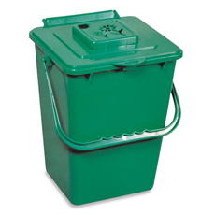](javascript:showOverlay('18448418625539P');)**Collect plant-based kitchen waste for composting by dropping it into a counter- top Compost Pail or crock. For some, lids come with a carbon filter that will keep odors down for months. (Filters can last a long time!)

**Items to compost are often considered “Green” or “Brown”**

Greens have more Nitrogen and Browns have more Carbon, and both are needed for compost. Here are some examples:

|  |  |
| --- | --- |
| **Nitrogen** | **Carbon** |
| Fruit & Vegetable scraps | Bread |
| Coffee grounds | Coffee filters and tea bags |
| Flowers | Dry leaves |
| Grass clippings | Egg shells |
| Barnyard manure | Hair and pet fur |
| House plants + soil | Shredded paper |
|  | Dry wood chips |

Yes to orange (citrus) and banana peels, melon rinds, and small seeds. Yes to mushrooms, rice, pasta, and crumbs! Most things break down eventually except for peach pits, but they do not hurt anything either.

Chop or break it up as much as desired: The smaller the pieces, the faster they will compost.

**Do Not Compost:**

Plastic (Of course!, but please remove plastic fruit stickers on peels, and don’t put in those coffee pods.)

Avoid meat, fish, dairy products, dog and cat food or droppings, spent tissues, and seeds of things that could become weeds.

Don’t drain oil into it, and of course, no cleaning products.

Check online for many great ideas about composting. There is much advice out there.

Many methods work, some just take longer than others.

**TAKING IT OUTSIDE**

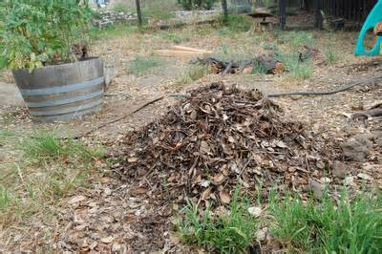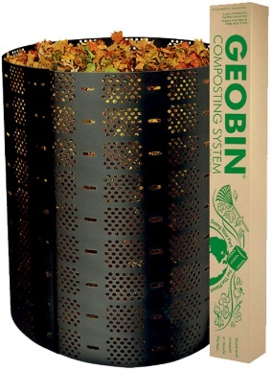Your Bin. You can make a pile on the ground, construct a simple enclosure, or try a fancier setup. A good size is about 3 feet high and 3 feet wide (unless you have a lot of materials, in which case, go bigger!). It need not be fancy! If animals disturb it, you could cover it with a tarp and weight it down with some rocks.

Load it Up! Try for more or less equal proportions “green” waste and “brown” waste. If you can, layer the greens and browns.

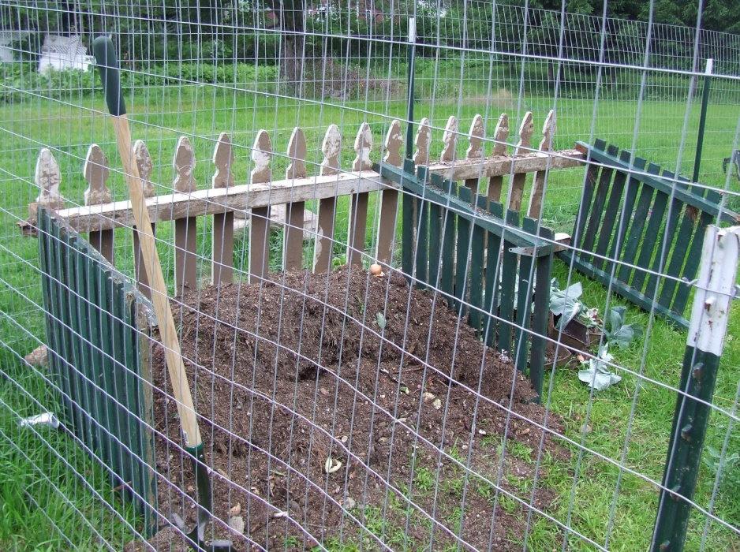Outside, keep the pile moist but not wet. It should feel damp, but water should not drip out when you squeeze it.

The healthy bacteria and fungi which do the work need Oxygen to breathe, so don’t drown them!

Mix it up every couple of weeks. You can sort it out with a shovel and set aside any material which has turned into compost. Mix the remains back together and let it keep doing its natural decomposition. They call this “turning” the pile.

Troubleshooting:

|  |  |  |
| --- | --- | --- |
| **Symptom** | **Problem may be…** | **Solution may be…** |
| A bad smell (not earthy) | * Too much moisture. * Too much Nitrogen-rich materials in pile | * Turn the pile. * Allow it to dry. * Add dry leaves or shredded paper. |
| Nothing seems to be happening | * Too dry. * Pile not big enough yet. * Too much Carbon-rich materials in pile. * Waste is in big chunks. | * Add water. * Add more greens *and* browns and be patient. * Ensure it has enough greens and/or add manure. * Chop materials into smaller pieces. |
| Pile is attracting pests | * Pile is exposed or in a convenient location for rodents, etc. * It has particular items they find attractive! * Some bugs are helpful, and worms are desirable! | * Create a barrier, or cover it. * Make sure to not add animal waste. * Make sure it’s mixed and moist. |

Composting can become a family hobby. It may generate some “heated” discussions over best practices ☺. Oh the joy of arguing about healthy things for which there are no perfect answers: That’s Life!