**MORE IDEAS!!**

Bishop Waste Disposal, <https://www.bishopwaste.com/> or (760) 872-6561 can bring you a dumpster or **rolloff**. The bigger, the more expensive, but it’s still easier than doing it all yourself. Maybe consider having neighbors or relatives pool together and get one delivered. However, be aware, there are some restrictions on what can be put in them.

Want to organize a **neighborhood cleanup**? The Tribal Env. Dept. has resources (vests, pickers, and advice). If you’re willing to organize and advertise, the Env. Dept. is willing to work with you to make it a successful event.



*SATISFACTION*

*Your few hours of hard work are done! Sit back, relax, feel the glow of relief and pleasure from knowing you’ve accomplished good work.* 

For more information, Contact the Tribal Environmental Department:

Gregory Spratt, Solid Waste Technician, (760) 938-2003 ext. 237 ([g.spratt@bigpinepaiute.org](mailto:g.spratt@bigpinepaiute.org) ) or Sally Manning, Environmental Director

(760) 938-2003 ext. 233 ([s.manning@bigpinepaiute.org](mailto:s.manning@bigpinepaiute.org) ).

Keep in touch and give us suggestions! Do you have an idea the Tribe should consider?

Contact us if you want to get more information on recycling or composting.

GETTING

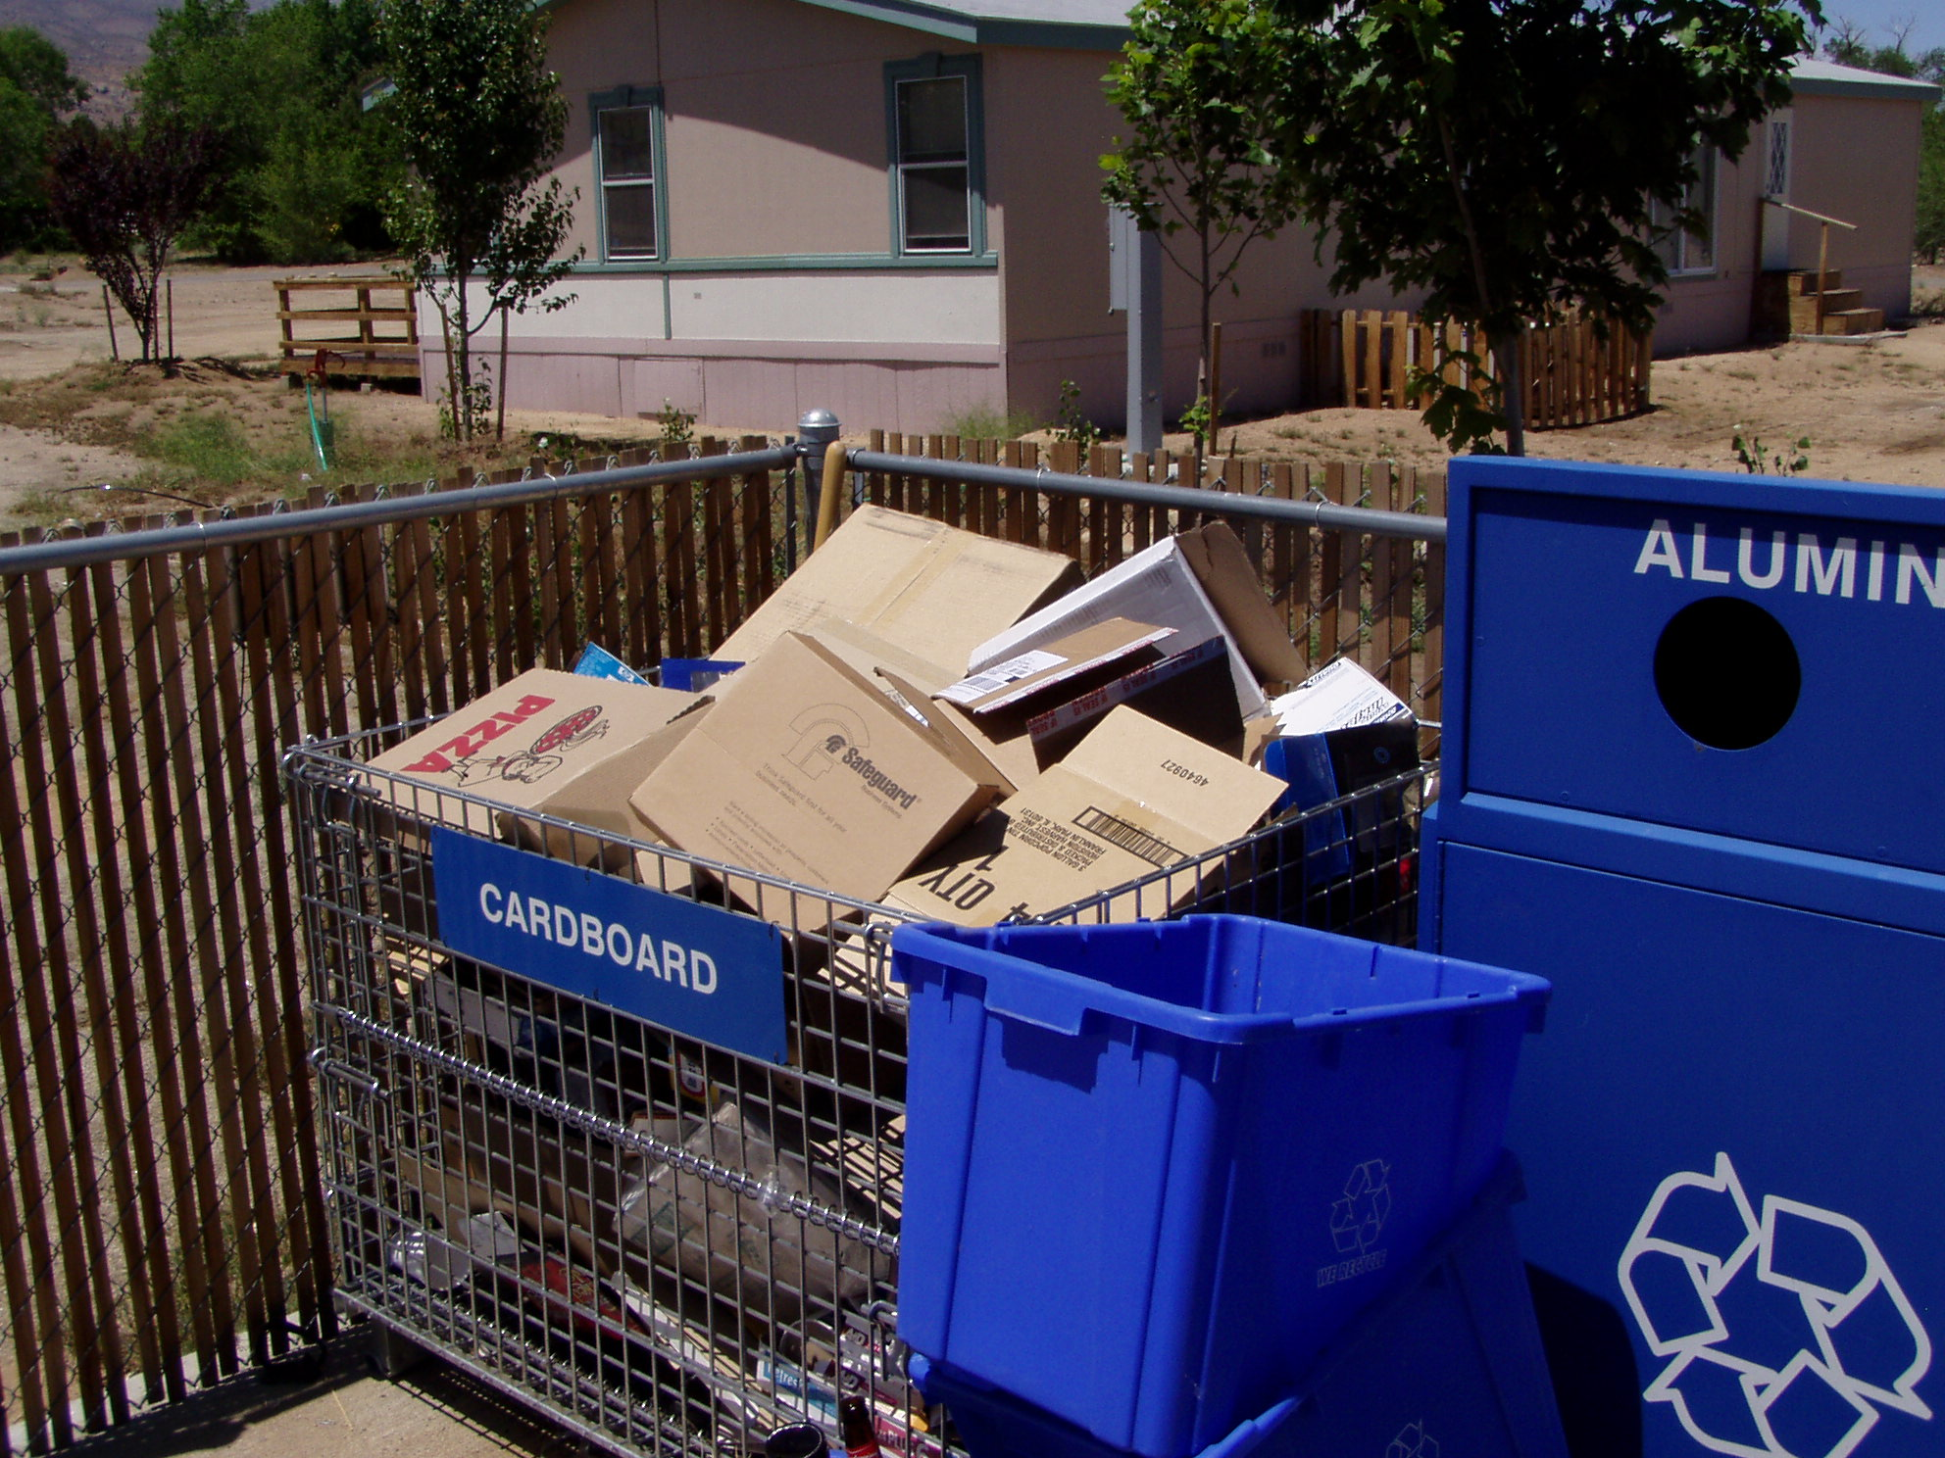

CLEAN!

**Want to feel better? Try this: *Cleaning*!**

* **Perfectly clear morning air that lets you see all the colors of the mountains!**
* **A clean kitchen when you get home from work!**
* **A washed car, inside and out!**
* **A shower after a day outdoors!**

**Think about it. Do these things lift your spirits? What about around your home? Everyone has a chore or two that has been put off. While never fun to *start*, think of the reward at the end: It will be DONE, and YOU will be HAPPY!**

***Clean and Be Happy!* The Tribal Environmental Department is passing along suggestions to get you going. Why? You will feel better, your home will be safer, risks of fire will be reduced, and you may reconnect with special people in the process. Also, the Env. Dept. has advice, resources, and other assistance to help.**

**Read this brochure, then get started!**

**TAKE ACTION!**

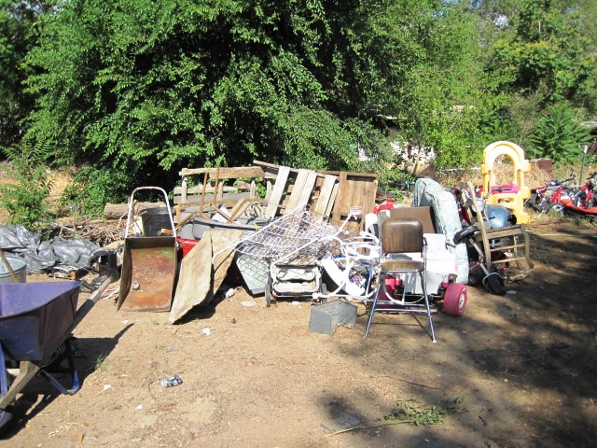

**Before starting, Make a Plan**. When can you do the project? What tools, supplies, and clothing will you need? (Think: clippers, rakes, ladders, bins, bags, gloves, masks, long pants, boots.) What is the final destination for the waste? Is it mixed waste requiring separation? Can you enlist some help? Be sure to take “before” and “after” pictures!

A plan makes it easier for you to **ask for help**. Explain the plan to your helper. What do they need to prepare for? Do they have a better idea? Offer to provide lunch or some other small reward, and help will be on its way!

Below are some suggestions to motivate you to get started:

Pick a section of your yard to tidy up. Gather the necessary tools and supplies, summon your helpers (but start without them if they don’t show), then get going. Try to work for an hour straight, then take a short break. Turn on some music! Resume and keep going, because progress is being made.

**High-level cleaning of the whole yard**: Gather up all the debris throughout or alongside your yard and make piles of related things in an accessible place. Piles could be:

**(1) stuff to keep;**

**(2) waste metal;**

**(3) recyclable plastic, glass, and clean cardboard;**

**(4) yard waste;**

**(5) trash (degraded paper, misc. plastics, rope, fabric, etc.); and**

**(6) waste construction debris (if you have it).**

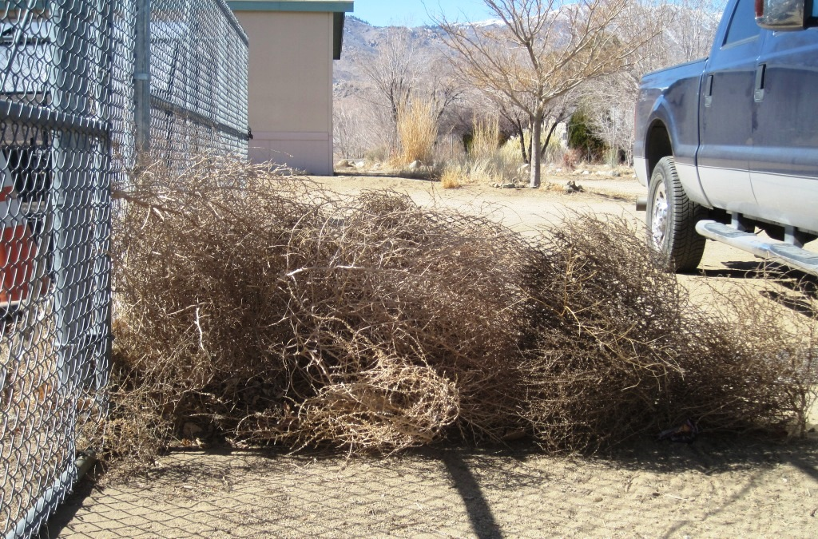

Recycle any metal, appliances, and other recyclables (Call us for help!). Toss trash and yard waste in your curbside waste bin, or, load separately and safely into a vehicle for transport to the Big Pine Transfer Station (open on Tuesdays and Saturdays). It may cost ~$5 to get rid of it, and this is absolutely money well-spent!

**Household Hazardous Waste = HHW:** Face it, if you haven’t used that oil, paint, cleaner-stuff, or pesticide in the past couple of years, you are not going to use it. Those bottles of mixed chemicals are a Hazard to you, the air, children, Elders, pets, and wildlife. With more hot days, fires, wind, or freak storms, the chance of leakage--or worse--is real, and this is dangerous. Check for (monthly) Inyo County HHW collection days when you can get rid of these toxins for FREE!

**Weeds**: It’s time to deal with them. Dying weeds and overgrown grass and brush are flashing a warning at you *“Fire Hazard! Fire Hazard!”* Make a plan, gather the tools, call your helper, and get busy. You will be glad you did. Weeds can go into your curbside bin, but if there are a lot, it’s best to haul them off to the Transfer Station and pay the nominal fee or plan it for a Free Green Waste Day. (Then go to your helper’s place and help them with their weeds.)